Unit 1 My Role Model

A
2. She is a figure skater who won many medals.
3. He is a soccer player who won many championships.
4. She is an actress who starred in many movies.

B
2. As a result, Mother Teresa decided to found a charity.
3. As a result, Nelson Mandela won the Nobel Peace Prize in 1993.
4. As a result, Angelina Jolie became one of the most famous actresses.

C
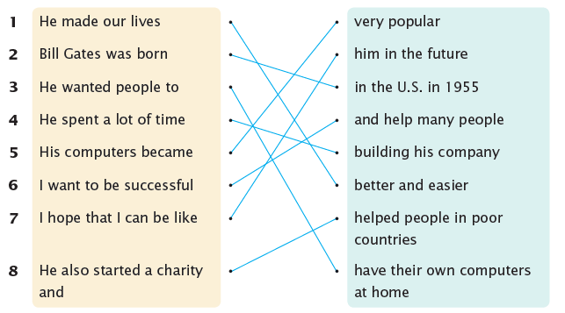
1. He made our lives better and easier.
2. Bill Gates was born in the U.S. in 1955.
3. He wanted people to have their own computers at home.
4. He spent a lot of time building his company.
5. His computers became very popular.
6. I want to be successful and help many people.
7. I hope that I can be like him in the future.
8. He also started a charity and helped people in poor countries.

Unit 2 I Have a Bad Habit

A
2. This will fill me up and keep me healthy.
3. This will make me feel sleepy and relaxed.
4. This will use up my extra energy.

B
2. Instead of tapping my feet, I will stand up and stretch.
3. Instead of watching TV, I will close my eyes and breathe deeply.
4. Instead of playing for hours, I will use my phone for thirty minutes.

C
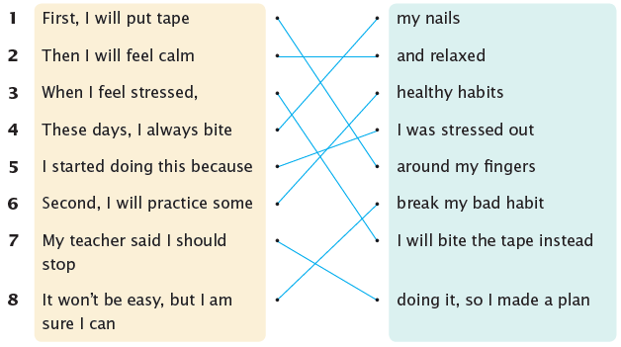

1. First, I will put tape around my fingers.
2. Then I will feel calm and relaxed.
3. When I feel stressed, I will bite the tape instead.
4. These days, I always bite my nails.
5. I started doing this because I was stressed out.
6. Second, I will practice some healthy habits.
7. My teacher said I should stop doing it, so I made a plan.
8. It won’t be easy, but I am sure I can break my bad habit!

Unit 3 A Restaurant Review

A
2. Both the sushi rolls and the noodles tasted great.
3. Both the beef tacos and the chicken burritos tasted delicious.
4. Both the hamburgers and the French fries tasted wonderful.

B
2. He made us wait for a long time.
3. She made us smile.
4. She made us try the food.

C
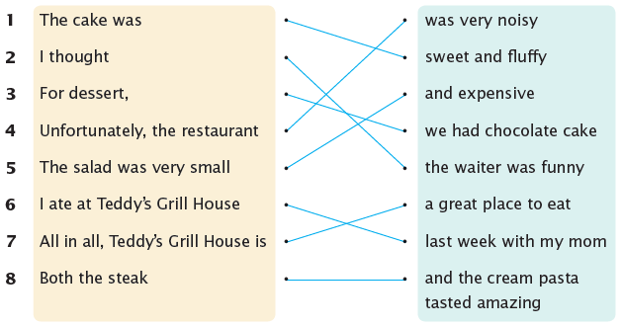

1. The cake was sweet and fluffy.
2. I thought the waiter was funny.
3. For dessert, we had chocolate cake.
4. Unfortunately, the restaurant was very noisy.
5. The salad was very small and expensive.
6. I ate at Teddy’s Grill House last week with my mom.
7. All in all, Teddy’s Grill House is a great place to eat.
8. Both the steak and the cream pasta tasted amazing.

Unit 4 I Have a Problem

A
2. Please tell me how to fix this!
3. Please tell me how to cure this!
4. Please tell me how to make friends!

B
2. If your acne gets worse, you had better see a doctor.
3. If your clumsiness gets worse, you had better try yoga.
4. If your problem gets worse, you had better talk to your teacher.

C
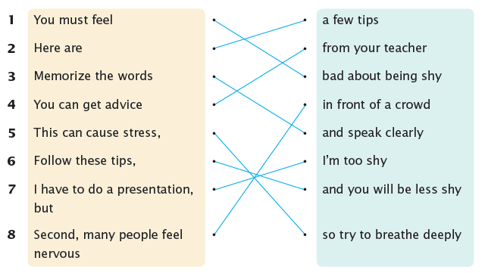

1. You must feel bad about being shy.
2. Here are a few tips.
3. Memorize the words and speak clearly.
4. You can get advice from your teacher.
5. This can cause stress, so try to breathe deeply.
6. Follow these tips, and you will be less shy!
7. I have to do a presentation, but I’m too shy.
8. Second, many people feel nervous in front of a crowd.

Unit 5 My Favorite Musical Genre

A
2. Dance music is performed by a DJ or a singer.
3. Hip hop is performed by a singer or a rapper.
4. Jazz is performed by a small band.

B
2. If you like energetic music, why don’t you listen to rock?
3. If you like relaxing music, why don’t you listen to jazz?
4. If you like exciting music, why don’t you listen to dance?

C
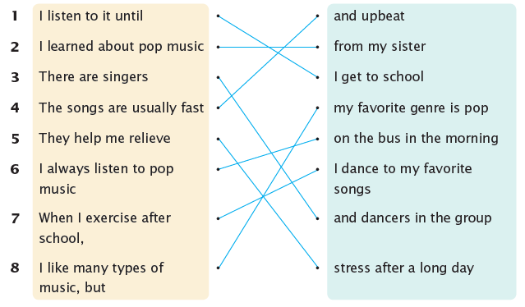

1. I listen to it until I get to school.
2. I learned about pop music from my sister.
3. There are singers and dancers in the group.
4. The songs are usually fast and upbeat.
5. They help me relieve stress after a long day.
6. I always listen to pop music on the bus in the morning.
7. When I exercise after school, I dance to my favorite songs.
8. I like many types of music, but my favorite genre is pop.

Unit 6 My Favorite Holiday

A
2. Cooking the dumplings is so much fun.
3. Making the chocolates is very difficult.
4. Flying the kite is so exciting.

B
2. We give away the delicious treats that we made.
3. We light the fireworks that we bought.
4. We exchange the gifts that we wrapped.

C
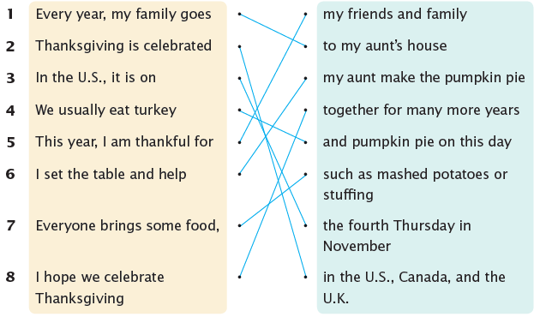

1. Every year, my family goes to my aunt’s house.
2. Thanksgiving is celebrated in the U.S., Canada, and the U.K.
3. In the U.S., it is on the fourth Thursday in November.
4. We usually eat turkey and pumpkin pie on this day.
5. This year, I am thankful for my friends and family.
6. I set the table and help my aunt make the pumpkin pie.
7. Everyone brings some food, such as mashed potatoes or stuffing.
8. I hope we celebrate Thanksgiving together for many more years!
Unit 7 Volunteering

A
2. I always felt much better after helping the animals.
3. I always felt much calmer after teaching the children.
4. I always felt much happier after serving the food.

B
2. Although I am a teenager, I’m glad that I can help the residents.
3. Although I am not a chef, I’m glad that I can serve the homeless.
4. Although I am not a teacher, I’m glad that I can teach the children.

C
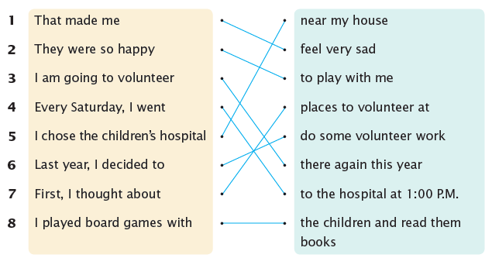

1. That made me feel very sad.
2. They were so happy to play with me.
3. I am going to volunteer there again this year.
4. Every Saturday, I went to the hospital at 1:00 P.M.
5. I chose the children’s hospital near my house.
6. Last year, I decided to do some volunteer work.
7. First, I thought about places to volunteer at.
8. I played board games with the children and read them books.
Unit 8 Book Report

A
2. It is about a funny girl named Pippi.
3. It is about a young boy named Auggie.
4. It is about a special girl named Matilda.

B
2. The story was very heartwarming to read.
3. The story was very entertaining to read.
4. The story was very interesting to read.

C
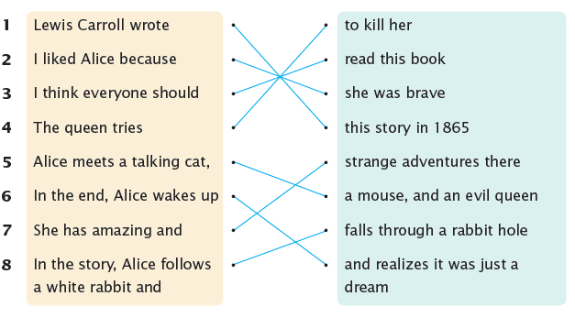

1. Lewis Carroll wrote this story in 1865.
2. I liked Alice because she was brave.
3. I think everyone should read this book.
4. The queen tries to kill her.
5. Alice meets a talking cat, a mouse, and an evil queen.
6. In the end, Alice wakes up and realizes it was just a dream.
7. She has amazing and strange adventures there.
8. In the story, Alice follows a white rabbit and falls through a rabbit hole.

